

**INDIVIDUAL ASSIGNMENT**

**TECHNOLOGY PARK MALAYSIA**

**CT010-3-1-PYP**

**PYTHON PROGRAMMING**

**APD1F2111/APU1F2111 – CE/ME/PE/EEE/TE/ CS/CS(CYB)/CS(DF)/CS(IS)/SE/IT/CGD/MMT**

**HAND OUT DATE: 10TH JANUARY 2022**

**HAND IN DATE: 7TH MARCH 2022**

**WEIGHTAGE: 100%**

**NAME: JACKY WONG CHUN KIT**

**TP NUMBER: TP066984**

**INSTRUCTIONS TO CANDIDATES:**

1. Submit your assignment online in MS Teams unless advised otherwise
2. Late submission will be awarded zero (0) unless Extenuating Circumstances (EC) are upheld
3. Cases of plagiarism will be penalized
4. You must obtain at least 50% in each component to pass this module

**TABLE OF CONTENT**

**Introduction** 3

**Assumptions** 4

**Design – Pseudocode** 5

**Design – Flowchart** 17

**Program Source Code with Explanation** 48

**Screenshot of Sample Input/Output with Explanation** 59

**Conclusion** 87

**References** 88

## **Introduction**

Three suppliers provide the state’s Department of Health with a variety of Personal Protective Equipment (PPE) items including head cover, face shield, mask, gloves, gown, and shoe cover. These items must be managed and required distribution to specific hospitals. Therefore, the department needs a computerized program that includes functions like creation of initial item inventory, functionalities of update, track, and search on item inventory. The items that are received by suppliers and distributed to hospitals must be recorded in required files, together with the details provided by the suppliers and hospitals. The number of items also will be updated from time to time when a new supply or distribution record is added to the files.

## **Assumptions**

1. The user can log in with the existing username and password through this system.
2. The 6 PPE items should be added through the system although endless inputs are allowed.
3. The 3 or 4 suppliers or hospitals should be added through the system although endless inputs are allowed.
4. All records kept can be viewed in txt. file format with the help of the system.
5. The specific item data can be searched easily by entering the item code.
6. The update of item quantities, suppliers, and hospital details can be done easily.
7. The user must confirm their input when going through updating suppliers’ and hospitals’ detail pages while executing the system.
8. Items, suppliers, and hospital details can be viewed and sorted directly for the intended user.
9. The program can be terminated without any issues.
10. The system can run smoothly for all functionalities.

## **Design – Pseudocode**

## **Design – Flowchart**

## **Program Source Code with Explanation**

**Variable:**

1. **String**



The variable “quantity” is initially generated as an integer. The variable can convert from integer to string using “str” code.

1. **Integer**



The variable “stock_quantity” is holding information in terms of integer. Users would not be able to input any characters or symbols other than numbers.

1. **Boolean**





Variable x is set to 1 for True while 0 for False. If x is set to 1 which is True, next command will be executed.

**Operator:**

1. **Addition**





If it is used by string variables, combination of two or more string variables occurs. The output will be “hospital_code | hospital_name | hospital_address | hospital_phone”. When it is used by integer variables, two numbers are added numerically. The output will be the sum of variables “lists[3]” and “add_stock_quantity”.

1. **Subtraction**



It is used for subtraction between two integer variables numerically. The output will be subtraction of variable “distribution_stock_quantity” from variable “lists[3]”.

1. **Equal To**



It is used to verify whether the first and second variables are completely equal. Next command will be executed if the variable “stock_quantity” is proven that equal to 100.

1. **Greater Than**



It is used to determine the first variable is greater than second variable. Next command will be executed if “distribution_stock_quantity” is greater than “num” in integer variables.

1. **Lesser Than**



It is used to determine the first variable is lesser than second variable. Next command will be executed if “distribution_stock_quantity” is lesser than “num” in integer variables.

1. **And**



It is the combination of two conditions and used for verifying conditions are true before the command is executed. Only next command will be executed if both conditions are true which variable “username” is equal to variable “admin” and variable “password” is equal to variable “abc123”.

1. **String Upper Case**



The operator is used to convert alphabets inside a string into uppercase. Users can input alphabets and uppercase will be applied to the alphabets.

1. **Or**



It can return the first variable that responds to true or final variable in the expression. Next command will be executed if users prompt one of the inputs “HC”, “FS”, “MS”, “GL”, “GW”, or “SC” for variable “add_item_code”.

1. **In**



It is used to see if something is included within a variable. The program can execute for loop when “L” is presented inside the variable “newFile”.

1. **Rstrip and Split**



Rstrip eliminates the whitespace at the end of a line on the right while split convert the string into a list by splitting it using a delimiter. The variable “items” will be stripped of any unnecessary space and split with a delimiter “,” before being restored back to the variable.

1. **Sort**



It helps sort elements inside a list either ascending or descending order based on alphabetically or numerically. The list “all_item” will be sorted in ascending order alphabetically based on item name.

**Looping Structure:**

1. **For Loop**

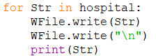

The program will walk through the first line of the variable “hospital”. Variable “Str” and a new line will be written inside hospital file then the line will be printed out. After being done with the first line, the next line will follow the same procedure as the first line. The loop will only stop executing when there is no more line detected in the variable “hospital”.

1. **While Loop & Break**

Users must input any item name when the command is executing. Users need to input the correct item name according to the condition “if”. If not, “Wrong format. Please try again” will keep looping until the users fulfilled the correct format of the item name to break the loop.

**Control Structure:**

1. **If-statement**



If users input the correct username and password, then the line “LOGIN SUCCESS!” will be printed.

1. **If-Else statement**

If the “ppe.txt” file is detected, the line “File already exist! Please proceed to Menu Page!” and users will stay at First Creation Confirm Page, else users will go to First Creation Page.

1. **If-Elif statement**

The input will be checked and if it is equal to “1”, then users will go to the “Update_Item_Page” function and breaks the loop after this. Else if it is equal to “2”, then users will go to the “Track_Item_Page” function and breaks the loop after this, and so on.

**Exception Handling:**

**Try and Except**

Users should enter the stock quantity in numerical form. If users input integer, then line “Input success!” will be printed and break loop. If otherwise, statement under the “except” block which the line “No other input is allowed!” will be printed and the loop continues. The program won’t crash even users entered invalid input.

**List:**

**Append List**



The variable “supplier_name” is appended and stored into the list “total_supplier”.

**File:**

1. **Write/Overwrite Data**

The file will write the strings with format “line[0],line[1],line[2],line[3]” and a new line. After done, it will be stored in the file.

1. **Append Data**



The file can write the strings with format “item_name,item_code,supplier_code,stock_quantity” without overwriting the file. After done, it will be stored in the file.

1. **Read Data**



The variable “newFile” is set to open and read the “ppe.txt” file without affecting the data inside the file.

**Functions:**





“Start_Up_Page()” function works as a starter and activator of the program.



“First_Creation_Confirm_Page()” function is to confirm whether users are first time executing the program.



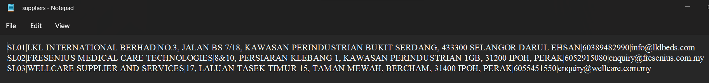

“First_Creation _Page()” function is to create the “ppe” and “suppliers” txt file through users’ input.



“Main_Menu_Page()” function as the center of program for executing all the functionalities.



“Update_Item_Page()” function is to select either update item quantities, suppliers, or hospitals’ detail.



“Increase_Item_Page()” function is to increase items’ stock quantities.



“Decrease_Item_Page()” function is to decrease items’ stock quantities and create or append the “distribution” txt file.



“Update_Supplier_Page()” function is to update suppliers’ detail.



“Update_Hospital_Page()” function is to confirm whether users are first time creating hospitals’ detail.



“Update_Detail()” function is to update hospitals’ detail.



“Create_Detail()” function is to create the “hospital” txt file.



“Track_Item_Page()” function is to track item inventory page for printing list.



“Search_Item_Page()” function is to search item inventory page for printing list.

**Modules:**



It is used to enable the program to auto-detect whether the file exists or not before executing the program.



It is implemented to print the latest date and time present.





It is implemented to validate the users’ input for preventing the wrong prompt.

## **Screenshot of Sample Input/Output with Explanation**

After start running the program, it shows me the welcome message and requires users to input their username and password.

If the username and password are both not matched, the user is unable to access to next command.

After entering the correct username and password, users need to prompt either if this first-time program is executed.

If users input “B” but they are first time executing the program, then it will show no existing data and requires users to input again.

If users enter input other than “A” or “B”, then users will get back to the Start Up Page.

After entering “A”, users will need to enter the item name.

If users input integer instead of characters, then users will be noticed “Wrong format” and input again.



After entering the item name, users will have to input the item code accordingly.



Same notification will be sent to users if entering the wrong format.



After entering the item code, users will have to input the supplier code accordingly.

Same notification will be sent to users if entering the wrong format.



After entering the supplier code, users will have to input stock quantity in boxes accordingly.

As initial stock quantities must be 100 each, therefore users must enter the integer “100” into the input.



After entering the stock quantity, users can decide either end by entering “X” or continue by any key input.

As users need to enter 6 different items with specific item codes, users must continue entering the item name, item code, supplier code, and stock quantity accordingly.

After users have entered all the required items, users can choose to stop input by entering “X”.

After entering “X”, the program will display all the items entered by users and proceed to create suppliers’ detail.

Same notification will be sent to users if entering the wrong format.



After entering the supplier code, users will have to input the company name accordingly.

If users leave the input blank, it will show no blank input is allowed and requires users to input again.



After entering the company name, users will have to input the company address accordingly.

Same notification will be sent to users if entering blank input.



After entering the company address, users will have to input the company phone number accordingly.

If users input any symbol or alphabet, it will show that the inputs are not allowed and require users to input again.



After entering the company phone number, users will have to input the company email address accordingly.

If users enter the invalid format of email address, it will show “Wrong format” and requires users to input again.

After entering the last detail, it will display the first supplier detail to the users. Users can either decide to continue or end by entering “X”.

As users need to enter 3 different suppliers with specific supplier codes, users must continue entering the supplier code, company name, address, phone number, and email address accordingly.

After entering the last supplier detail, users can choose to stop input by entering “X”.

This is the ppe.txt and suppliers.txt files that had created after the function.

Users will be brought to Main Menu Page after the items and suppliers’ detail are done. Users can choose any functionalities they wanted to execute.

Input other than 1 to 4 is not allowed as it shows wrong input by users and requires users to input again.

After entering “1” as “Update Item Inventory”, users will be brought to Update Item Page. Users can choose any option either to update item quantities, update supplier details, or back to Main Menu Page.

If users enter input other than “A”, “B”, “C”, “D”, or “E”, then it will show “Wrong input” and requires users to input again.

After selecting “A”, users will be brought to Increase Item Page. Users can firstly choose which item they wish to add in quantity by entering a specific item code.

If users enter an invalid item code, it will show “Invalid input” and requires users to input again.

After users enter the correct item code, users will have to input the stock quantity that needed to add.

If users do not enter the input integer, it will show “No other input” and requires users to input again.

After entering the stock quantity to add, it will display the item code, initial quantity, stock quantity added, and final stock quantity to users. Users can decide either to continue to add stock quantity by entering item code or back to Update Item Page by entering “X”.

This is the changes of ppe.txt file after the function.

Users will be brought back to Update Item Page after entering “X”. Users can continue to execute other updates or back to Main Menu Page.

After selecting “B”, users will be brought to Decrease Item Page. All item quantities will be displayed to users for convenience purposes. Users can firstly choose which item they wish to distribute in quantity by entering a specific item code.

If users enter an invalid item code, it will show “Invalid input” and requires users to input again.

After entering the correct item code, users can choose the amount of stock quantity to distribute based on the display given.

If users do not enter the input integer, it will show “No other input” and requires users to input again.

If the amount of distribution entered by users is more than the inventory stock quantity, users will be notified of the current stock quantity of the item and require users to retry with appropriate quantity.

After entering the appropriate amount of distribution, users will have to input the hospital code accordingly.

If users enter the invalid format of hospital code, it will show “Wrong format” and requires users to input again.

After entering the correct hospital code, it will show “Input done!”. Item code, hospital code, initial quantity, stock quantity distributed, and final stock quantity are displayed to users. Users can decide either to continue to decrease stock quantity by entering item code or back to Update Item Page by entering “X”.

This is the changes of ppe.txt file and the creation of distribution.txt file after the function.

After selecting “C”, users will be brought to Update Supplier Page. All supplier details will be displayed to users. Users can choose which supplier they wish to update detail by entering specific supplier code.

If users enter the invalid format of supplier code, it will show “Wrong format” and requires users to input again.

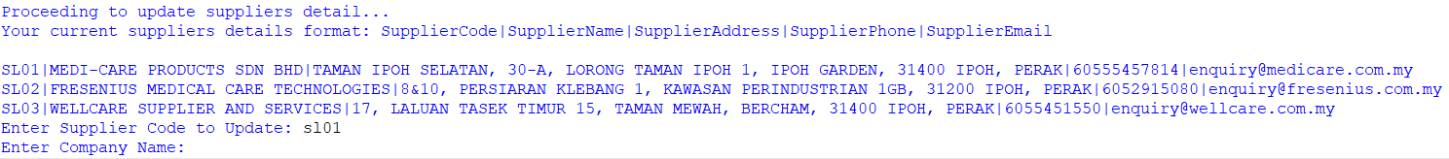

After entering the correct supplier code, users will have to enter again the company name, address, phone number, and email address accordingly with the correct format.

After done entering all the input required, it will show “Update done!” and it will show updated supplier details to users. Users can decide either to continue to update detail by entering any key or back to Main Menu Page by entering “X”.

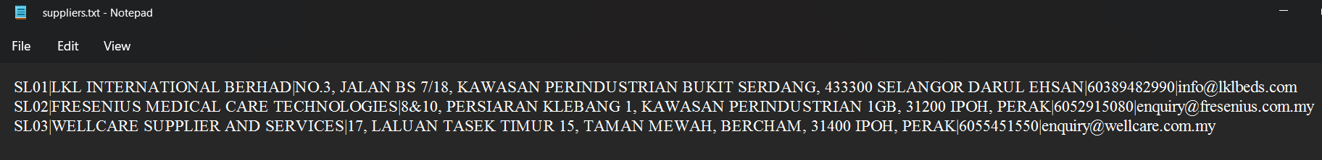

This is the changes of suppliers.txt file after the function.

After selecting “D”, users will be brought to Update Hospital Page. If users have not yet created hospital detail, this page will appear for users to create them.

Same notification will be sent to users if entering the wrong format.

After entering the hospital code, users will have to input the hospital name accordingly.

If users leave the input blank, it will show no blank input is allowed and requires users to input again.

After entering the hospital name, users will have to input the hospital address accordingly.

Same notification to users if leave the input blank and requires users to input again.



After entering the hospital address, users will have to input the hospital phone number accordingly.



If users input any symbol or alphabet, it will show that the inputs are not allowed and require users to input again.



After entering the hospital phone number, users will have to input hospital the email address accordingly.

If users enter the invalid format of email address, it will show “Wrong format” and requires users to input again.

After entering the last detail, it will display the first hospital detail to the users. Users can either decide to continue or end by entering “X”.

As users need to enter 3 different hospitals with specific hospital codes, users must continue entering the hospital code, hospital name, address, phone number, and email address accordingly.

After entering the last supplier detail, users can choose to stop input by entering “X”.

This is the creation of hospitals.txt file after the function.

Users will be brought back to Main Menu Page after the hospitals’ detail are done.

After selecting “D” again, users will be brought to Update Hospital Page. This time hospital details will be displayed to users. Users can choose which hospital they wish to update detail by entering specific hospital code.

If users enter the invalid format of hospital code, it will show “Wrong format” and requires users to input again.

After entering the correct hospital code, users will have to enter again the hospital name, address, phone number, and email address accordingly with the correct format.

After done entering all the input required, it will show “Update done!” and it will show updated hospital details to users. Users can decide either to continue to update detail by entering any key or back to Main Menu Page by entering “X”.

This is the changes of hospitals.txt file after the function.

After selecting “E”, users can go back to Main Menu Page without any issue.

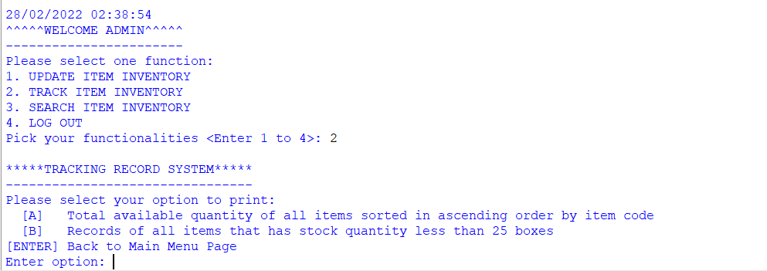

After entering “2” as “Track Item Inventory”, users will be brought to Track Item Page. Users can choose option A or B for the specific output, or the “Enter” key to back to Main Menu Page.

If users enter input other than “A” or “B”, then it will show “Invalid input” and requires users to input again.

After entering “A”, the program will display the total available quantity of all items sorted in ascending order according to item code. Users can decide either to continue by entering any key or back to Main Menu Page by entering “X”.

After entering “B”, the program will display records of all items that have stock quantity of less than 25 boxes. Users can decide either to continue by entering any key or back to Main Menu Page by entering “X”.

After entering “3” as “Search Item Inventory”, users will be brought to Track Item Page. Users will have to input item code that wishes to search for it.

If users enter an invalid item code, users will be notified and have to input again.

After entering the correct item code, it will show all the distributions to which hospital with displaying hospital code, item code, and stock quantity distributed. As if the item has been distributed to same hospital more than once, then their quantities will be summed up and displayed to users. Users can either continue searching by entering any key or back to Main Menu Page by entering “X”.

Users can log out from the system by entering “4” and will go back to the Start Up Page.

Users can just leave both inputs blank and the program will be terminated successfully by displaying “Thank you for using this program! See you!” to users.

## **Conclusion**

In conclusion, I had grasped the complexities of programming and coding throughout this assignment. Aside from that, I received additional experience and knowledge of how the state provider system operates. I discovered that certain systems appear easy on the surface, but they are difficult to program in real-time. I learned how to spot errors in programming faster along this voyage. Lastly, I aim to continue improving my programming skill for becoming a better programmer in the future.

# References

Admin, B. (2021, September 25). *Display the Current Date and Time in Python*. Programming, Pseudocode Example, C# Programming Example. Retrieved February 15, 2022, from <https://www.csharp-console-examples.com/programming-languages/python3/display-the-current-date-and-time-in-python/>

*Code Faster with Line-of-Code Completions, Cloudless Processing*. (n.d.). Kite. Retrieved February 2, 2022, from <https://www.kite.com/python/answers/how-to-edit-a-file-in-python>

*How to represents initialization of empty list in python into pseudocode*. (2015, April 27). Stack Overflow. Retrieved February 3, 2022, from <https://stackoverflow.com/questions/29886603/how-to-represents-initialization-of-empty-list-in-python-into-pseudocode>

*How to sort with lambda in Python*. (2010, September 22). Stack Overflow. Retrieved February 15, 2022, from <https://stackoverflow.com/questions/3766633/how-to-sort-with-lambda-in-python>

Python Tutorial. (2020, October 23). *How to Check If a File Exists in Python*. Python Tutorial - Master Python Programming For Beginners from Scratch. Retrieved February 14, 2022, from <https://www.pythontutorial.net/python-basics/python-check-if-file-exists/>

Shivanandhan, M. (2020, August 24). *Python While Loop Tutorial – Do While True Example Statement*. freeCodeCamp.Org. Retrieved February 22, 2022, from <https://www.freecodecamp.org/news/python-while-loop-tutorial-do-while-true-example-statement/>

Tagliaferri, L. (2021, August 20). *Understanding Lists in Python 3*. DigitalOcean Community. Retrieved February 3, 2022, from <https://www.digitalocean.com/community/tutorials/understanding-lists-in-python-3>